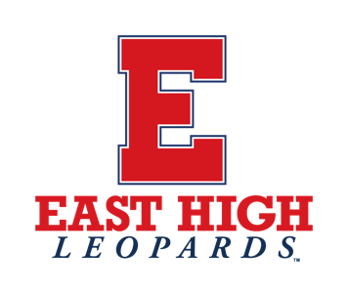
East High School Community Council Agenda
Tuesday, January 14th, 2025 at 4:30 pm
East High Library
840 South 1300 East, Salt Lake City, UT 84102

Welcome – Sara Farah, SCC Vice Chair

Public Comment (up to 15 minutes)
Individuals seeking to address the SCC may sign-up on the clipboard at the meeting and will have up to 3 minutes to speak. If we run out of time to hear everyone who wishes to speak, please send us your thoughts at the SCC Chair’s email: marycatherineperry@gmail.com

Review and Approval of November 12, 2024 Minutes – Sara Farah, SCC Vice Chair

Fundraiser Requests – Justin Spencer, Assistant Principal

School Counseling Advisory Report – Mark Unruh, School Counselor

SCC Discussion

- Cell Phone Policy Update
- Land Trust Budget 2023-24
- Land Trust Budget Planning 2024-25
- Follow up on Course Requests

Principal’s Report – Ryan Oaks, Principal
Student Government Report - Lynette Yorgason, Student Government Advisor
PTSA Report – Shannon Freedman
School Improvement Council (SIC) Report – Elena Martinova, SIC Chair

Additional Business

- Next Meeting: Tuesday, February 11th at 4:30 pm at Glendale Middle School

Adjournment

